**The Oscilloscope & Signal Generator**

**Lab 3**

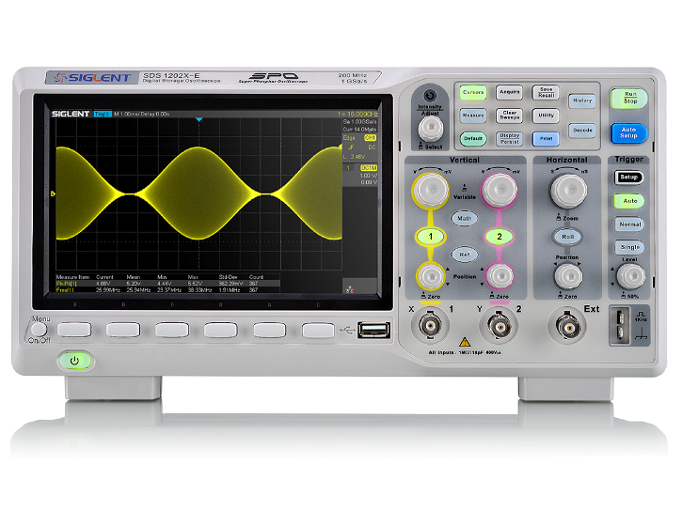

**ECE 1101 Lab, Section 6**

**Date: Thursday, September 12th, 2019**

**Kyler Martinez, Daniel Tan**

Equipment Used In The Experiment:

* Keysight Function/Arbitrary Waveform Generator 10Hz
  + Make/Model: 33210A
  + Serial Number: MY48017338
* Keysight InfiniiVision Digital Storage Oscilloscope 200 MHz
  + Make/Model: DSOX2022A
  + Serial Number: MY56041108
* Fluke Digital Multimeter
  + Make/Model: 8010A
  + Serial Number: 56708

Objective:

The objective of the lab was to learn how to operate the Oscilloscope, learn how to measure peak-to-peak, average and rms voltage. Another objective is to compare measurements made with an Oscilloscope with the theoretical values and the digital multimeter. The final objective of the lab was to compare rms voltage values using the digital multimeter and oscilloscope while increasing the frequency of the wave.

Background Theory:

The background theory used in the lab is that rms voltage can be calculated using the equations for a sine wave: Vp/(2).5, square wave: Vp, triangular wave: Vp/(3).5, where Vp is the peak-to-peak voltage. Another theory used in the lab is that the digital multimeter will begin to show less of the true value of the rms as the frequency of the AC voltage wave is increased.

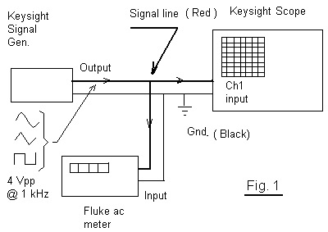

Procedure:

First set the signal generator to have a 4V peak-to-peak and 1 kHz wave. Then connect the oscilloscope, signal generator, and the fluke multimeter together as seen in figure one. Then use the oscilloscope to show the wave along with its measurements. Using the signal generator create sine, square, and triangle waves and take pictures of the output of the oscilloscope and their measurements.



For the rms experiment, calculate eighty percent of the agreed on rms and increase the frequency until the digital multimeter shows that value.

Data: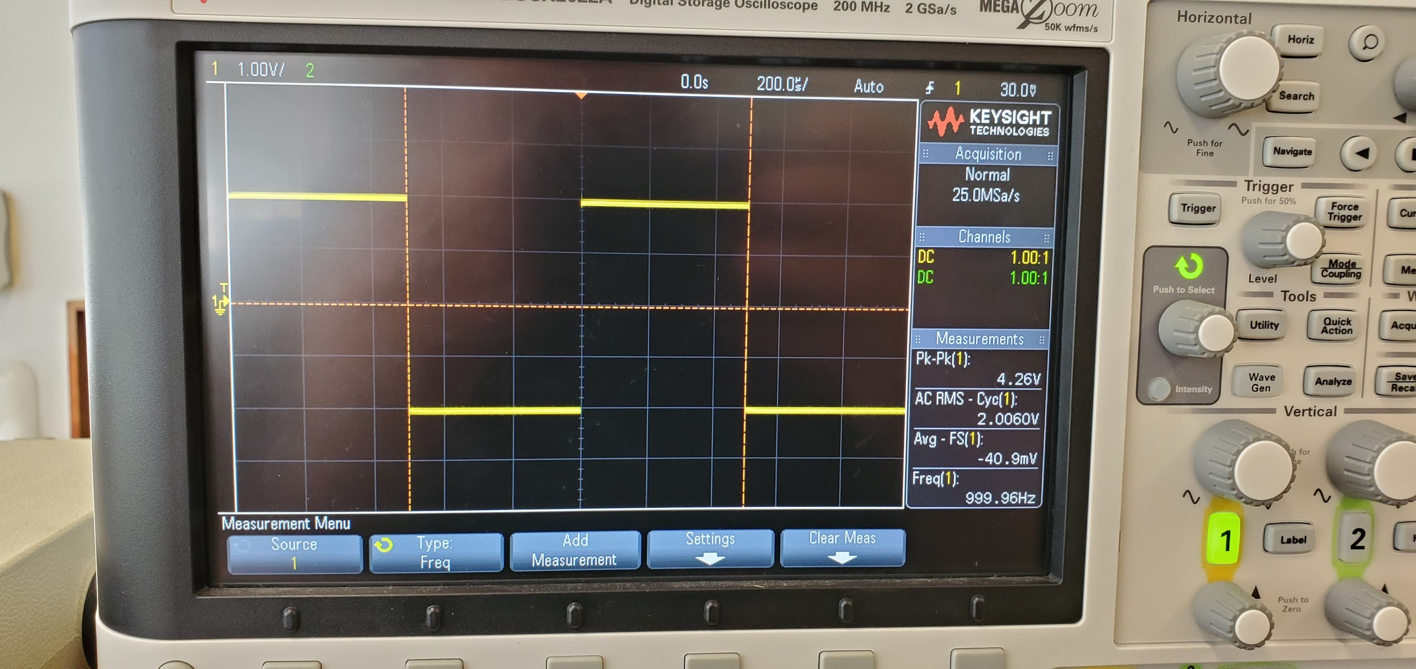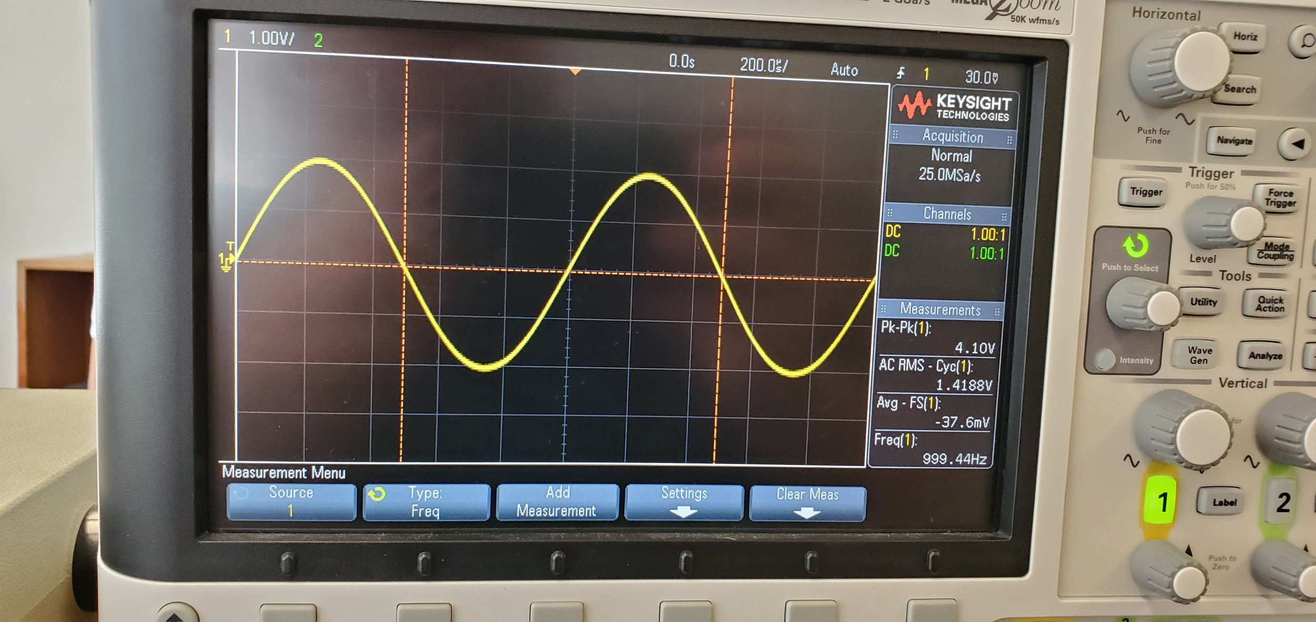

For the sine wave, the peak-to-peak voltage is 4.1 V, the average is -37.6 mV, the rms is 1.4188 V, and the frequency is recorded as 999.44 Hz.

For the square wave, the peak-to-peak voltage is 4.26 V, the average is -40.9 mV, the rms is 2.006 V, and the frequency is recorded as 999.96 Hz.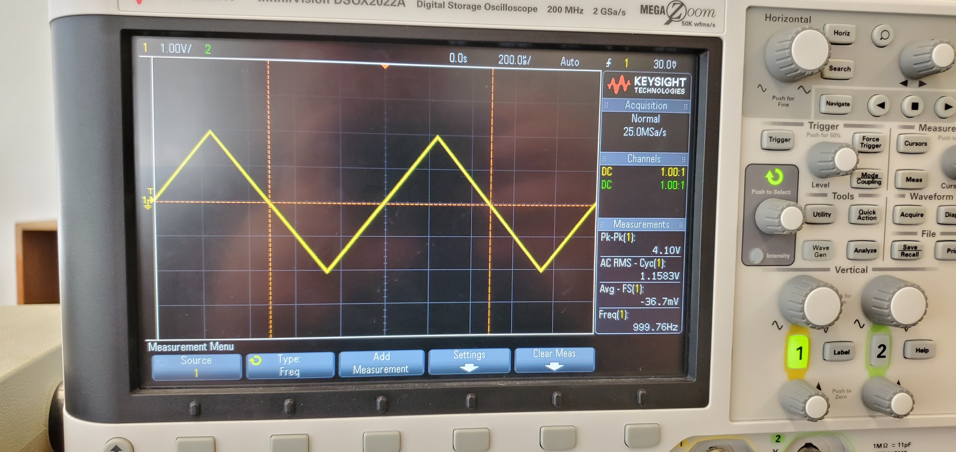

For the triangular wave, the peak-to-peak voltage is 4.1 V, the average is -36.7 mV, the rms is 1.1583 V, and the frequency is recorded as 999.76 Hz.

|  |  |  |  |  |
| --- | --- | --- | --- | --- |
| Waveform Type | Scope rms | DMM rms | Theory rms | Average rms |
| Sinusoidal | 1.4192 V | 1.414 V | 1.4496 V | 1.4276 V |
| Triangular | 1.1583 V | 1.156 V | 1.1836 V | 1.16597 V |
| Square Wave | 2.006 V | 1.997 V | 2.05 V | 2.0177 V |

Conclusion:

After using the machines, we determined that the oscilloscope deviated from the digital multimeter reading of the rms voltage which was about .005 volts about, but is still relatively close. This can be attributed to the fact that the oscilloscope kept reading about .1 or .2 volts above the peak-to-peak voltage we set on the signal generator, which can account for the variation in the rms value. The oscilloscope did, however, read the frequency closely to how we set it in the signal generator. Interference from other machines could have resulted in the oscilloscope reading a different value for the voltage. Overall the machines both read values of about .04 V below the theory.

**Post Lab: Lab #3**

Data:

|  |  |
| --- | --- |
| Waveform Type | % of variation |
| Sinusoidal | 1.541 % |
| Triangular | 1.512% |
| Square Wave | 1.601% |

Frequency Graph and Data Points:

rms Voltage Vs. Frequency For the Digital Multimeter

|  |  |  |  |  |  |  |  |
| --- | --- | --- | --- | --- | --- | --- | --- |
| rms (V) | 1.1312 | 1.012 | .346 | .678 | .921 | 1.329 | 1.325 |
| f (kHZ) | 403 | 501 | 1000 | 810 | 610 | 200 | 250 |

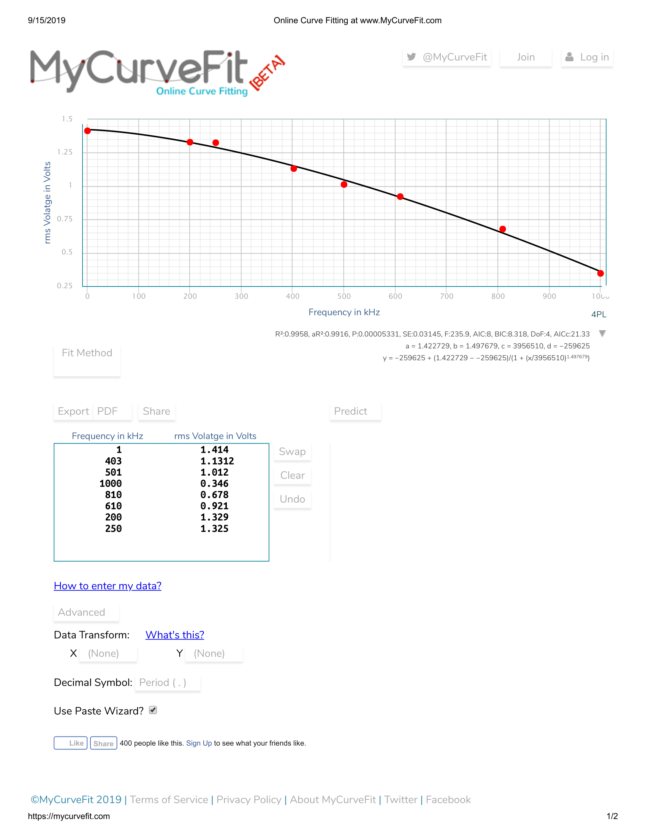

Graph with a curve of best fit for the data.

rms Voltage Vs. Frequency For the Oscilloscope

|  |  |  |  |  |  |  |  |  |
| --- | --- | --- | --- | --- | --- | --- | --- | --- |
| rms (V) | 1.419 | 1.419 | 1.419 | 1.419 | 1.419 | 1.419 | 1.419 | 1.419 |
| f (kHZ) | 403 | 501 | 1000 | 810 | 610 | 200 | 250 | 1 |

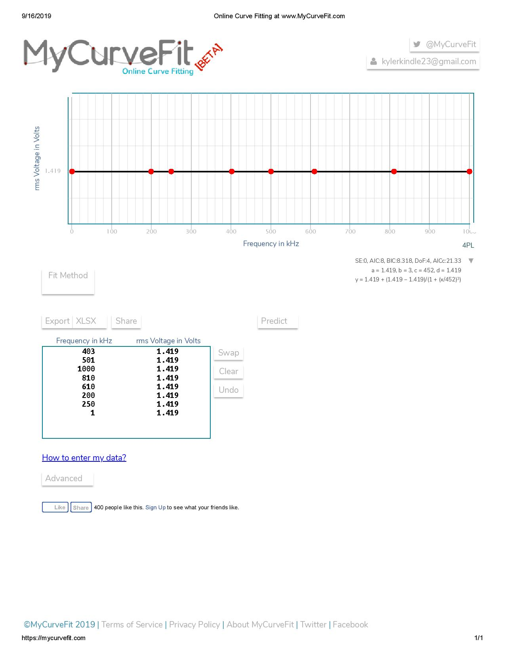

Graph with a curve of best fit for the data.

Conclusion:

The rms averages had about 1.5 to 1.6 percent of variation between them with the theoretical rms value typically being greater than the readings from the machines. When conducting the frequency response test, we determined that f20% was about 403kHz and the rms voltage was about 1.1312 V. We determined that around 403kHz, the digital multimeter (DMM) was showing an rms voltage of about 80% than what the oscilloscope shows. The graph of the curve of best fit for the DMM begins at a constant value and then continues to decrease, where the graph for the oscilloscope is a constant value thus showing that the oscilloscope can process waves with much higher frequencies while compared to the digital multimeter.